- UK CPI inflation held steady in August, due to the offsetting effects of weaker services inflation versus a further pickup in food and fuel prices. Base effects will push up headline inflation in September, but this should mark the peak. Subsequently, we expect inflation to drift lower over the final months of this year and through 2026.
- Today's data was broadly as expected and didn't hint at any shifts in the underlying drivers of inflation. We have taken on board Ofgem's recent energy price cap announcement, so we think the energy category is likely to provide a smaller drag over the next year. But this shift wasn't enough to alter our annual CPI inflation forecast of 3.5% in 2025 and 2.8% in 2026.
CPI inflation was unchanged at 3.8% in August. The flat outturn was the result of a series of small offsetting forces. Food price inflation continued to climb and there was a smaller drag from the fuel category, as petrol prices rose 0.4% m/m between July and August, versus a 1.5% drop between those months last year. By contrast, services inflation cooled, which was largely due to July's sharp rise in air fares unwinding. Elsewhere, RPI and RPIX inflation fell to 4.6% and 4.4% respectively in August, from 4.8% and 4.7% in July.
We expect headline inflation to rise slightly in September, primarily due to base effects in the fuel category. But this will almost certainly mark the peak for inflation, with base effects from last year's chunky increase in the energy price cap likely to result in a much smaller positive contribution from the energy category from October. We then expect inflation to drift downwards through 2026, as upward pressure from the food category starts to fade and the resilience in services inflation gradually gives way.
At the end of last month, Ofgem announced that its energy price cap will increase by 2% on October 1. This was fractionally higher than we had anticipated, primarily reflecting stronger-than-expected rises in the non-wholesale cost components of the price cap. Therefore, we now think the energy category will provide a slightly smaller drag on headline inflation over the next year. However, this shift wasn't large enough to materially alter our forecast, so we still expect CPI inflation to average 3.5% in 2025 and 2.8% in 2026.
Chart 1: We still forecast CPI inflation to average 3.5% this year and 2.8% in 2026
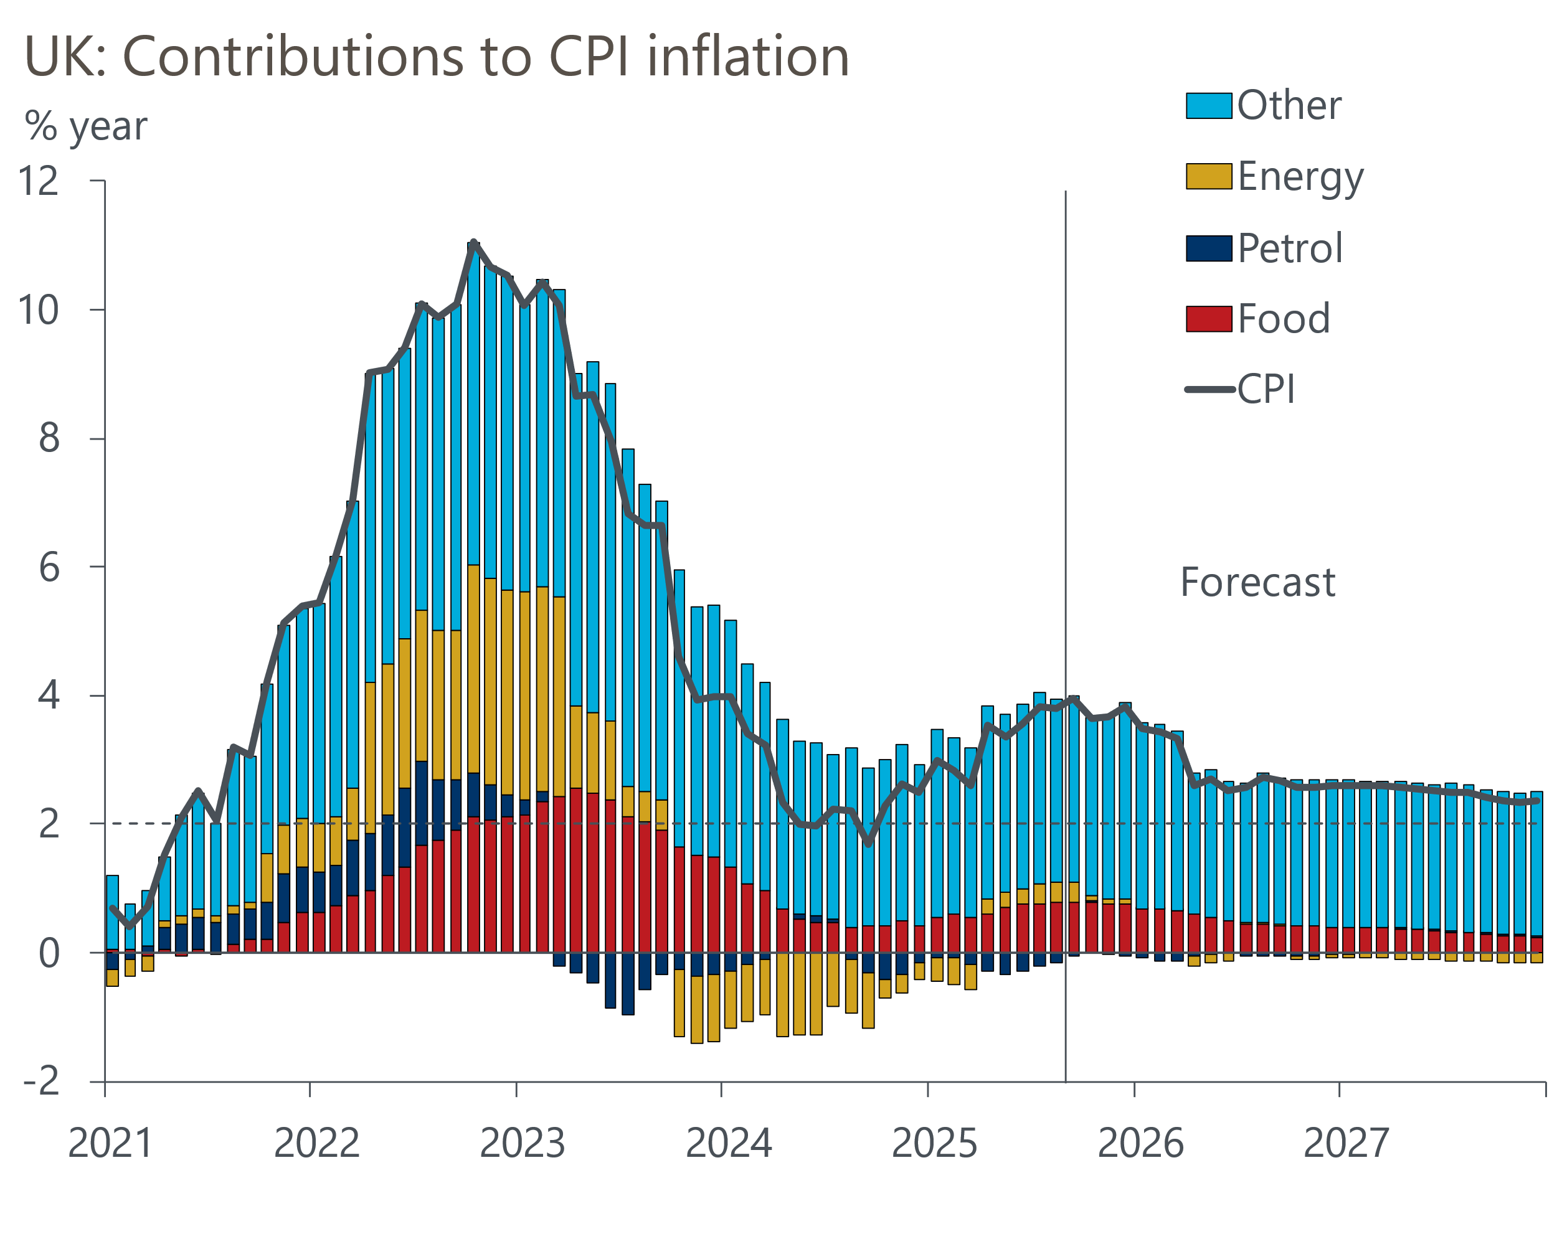
Source: Oxford Economics, Haver Analytics

